1. Create one folder
2. Download code from mail in that folder.
3. Extract file of code.
4. Open Eclipse
5. Select workspace. Select folder where the project is mentioned. The below mentioned image is for your guidance.
6. 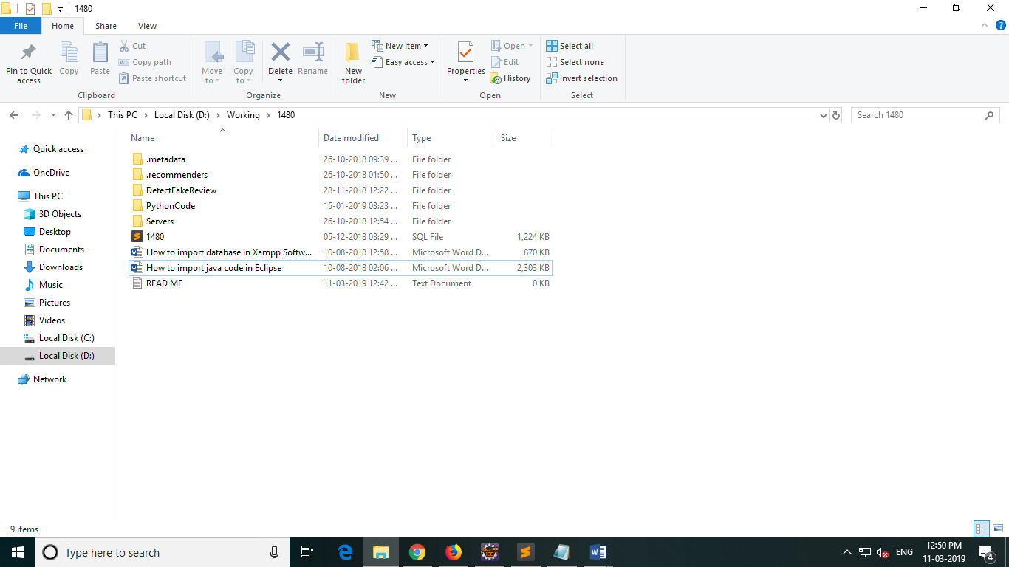

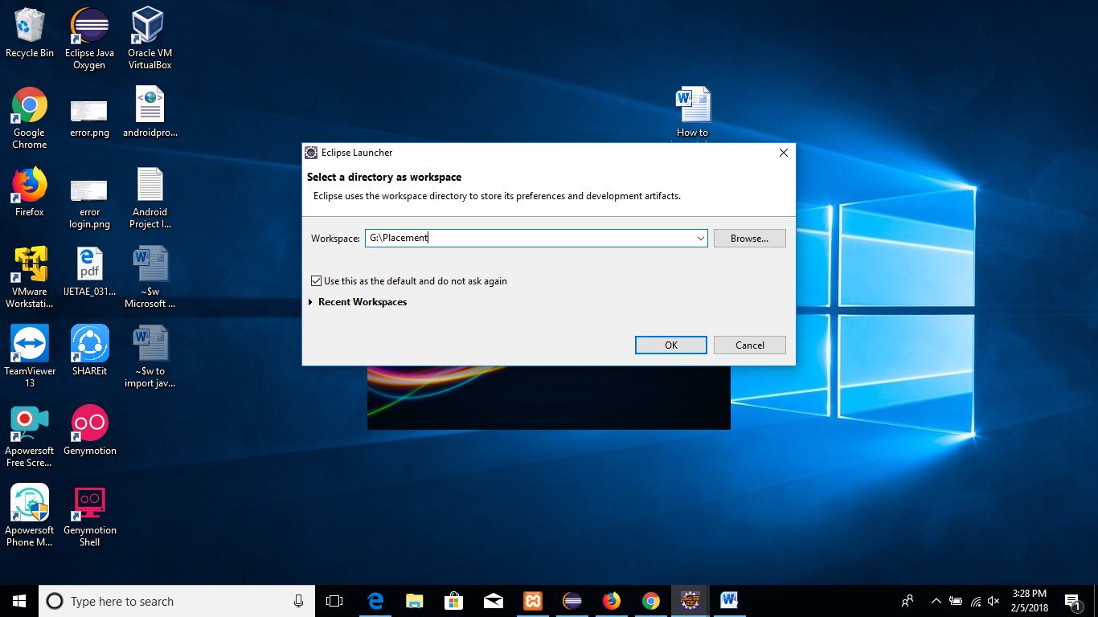

* If the project has error symbol as shown in the below image

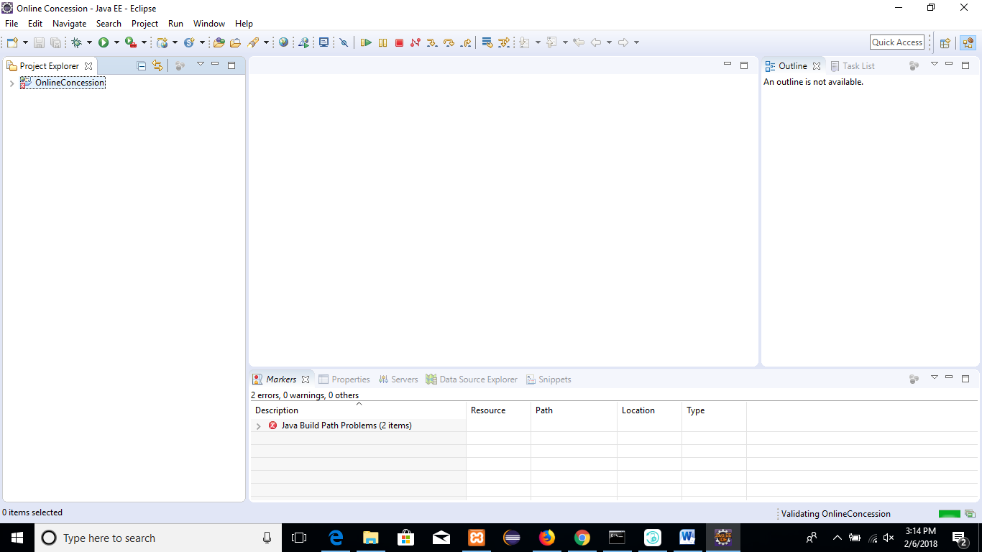

1. Right click on Project name
2. Select Properties.

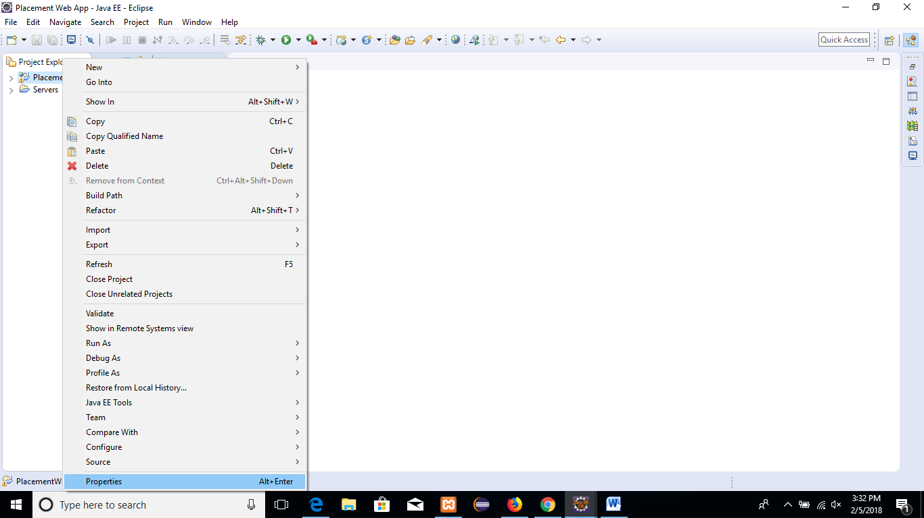

1. Select Java Build Path-> libraries

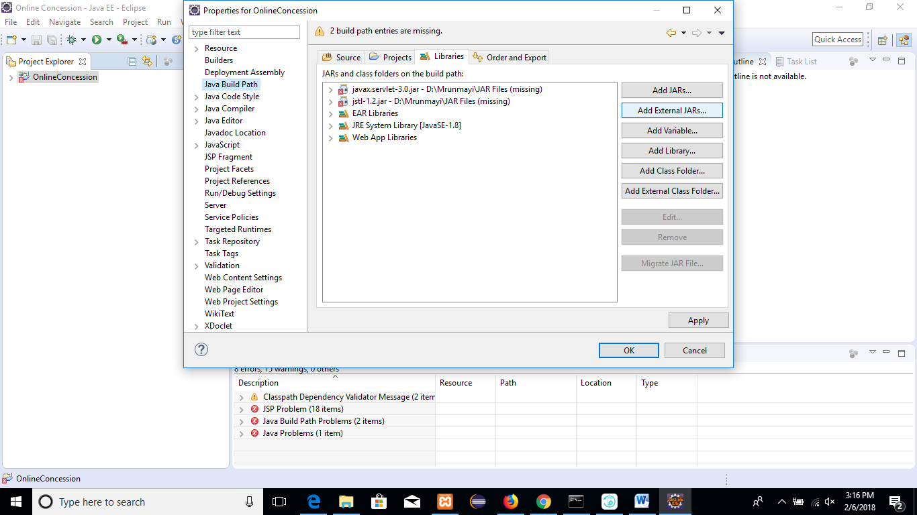

1. Click on JRE System Library and click on remove button

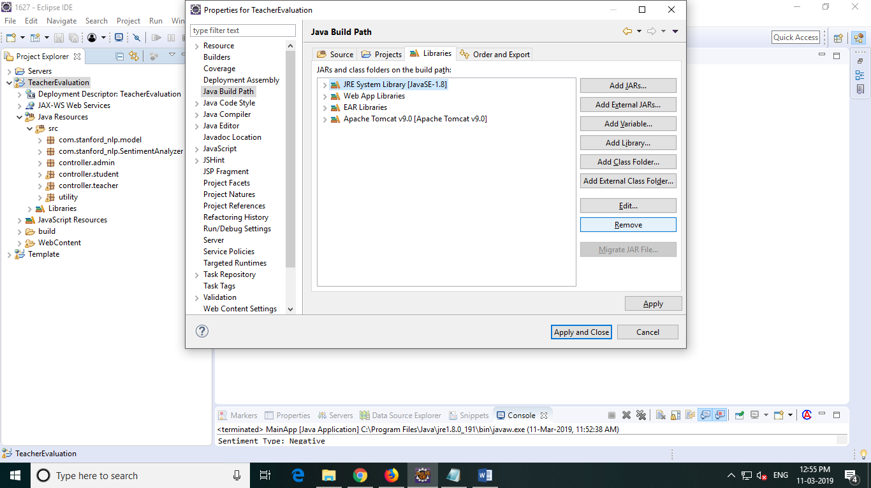

1. Then Click on Add Library

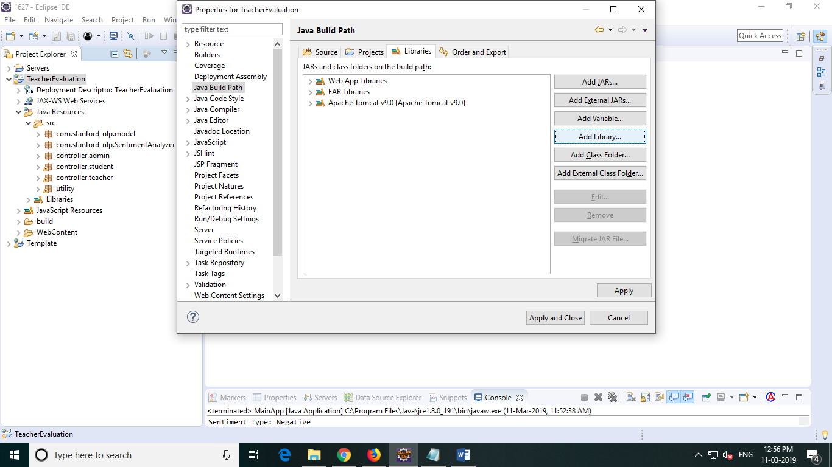

1. Select JRE System Library -> Next

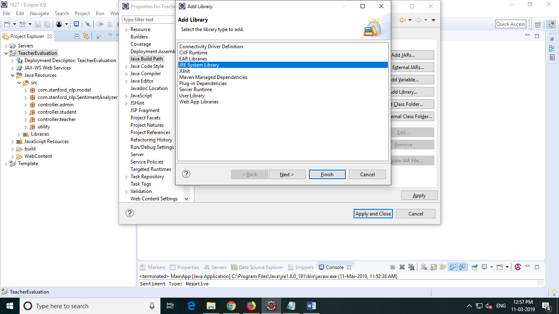

1. Then Click on Finish

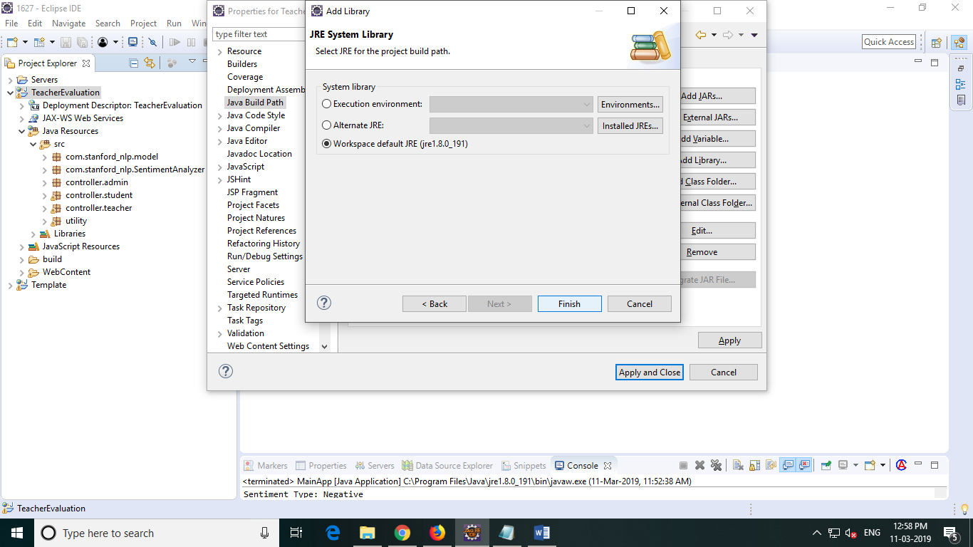

1. Click on Apply amd Close
2. Click Ok.
3. Now run your project.
4. Select Run-> Run on Server

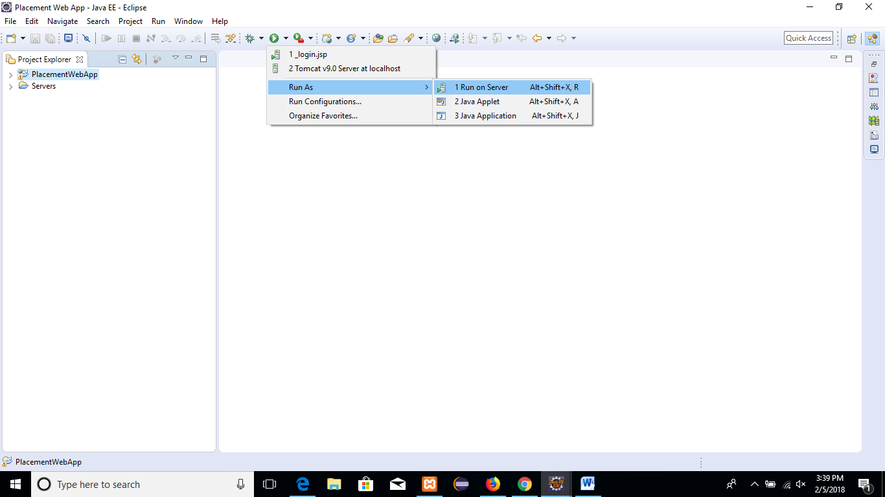

1. Manually Define a new Server if server is not present in the workspace else click on finish

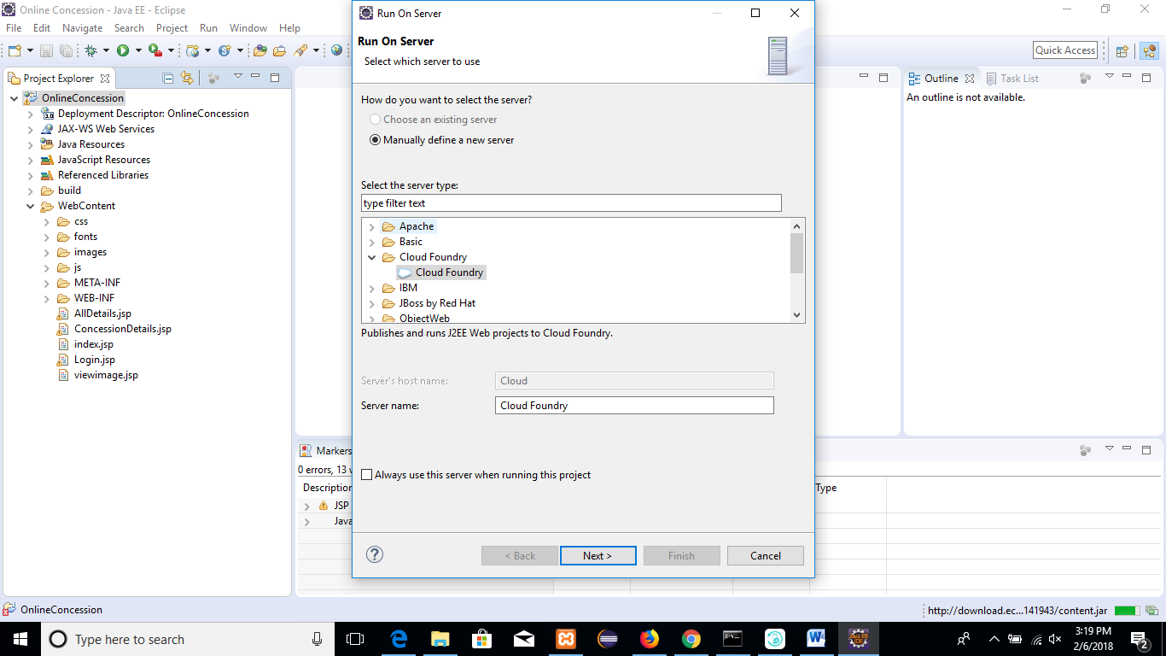

1. Select Apache
2. Tomcat 9.0

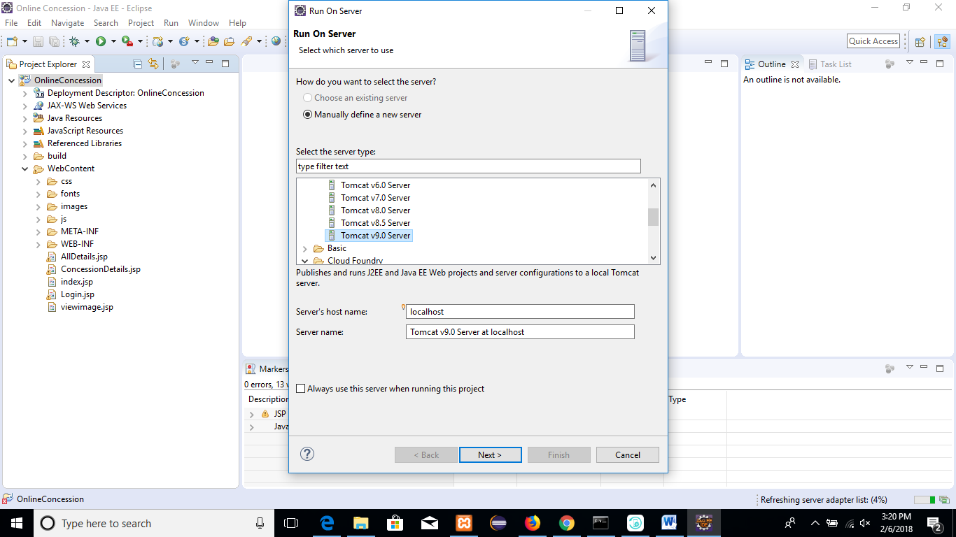

1. Then Browse it from C:\Program Files\Apache Software Foundation\Tomcat 9.0

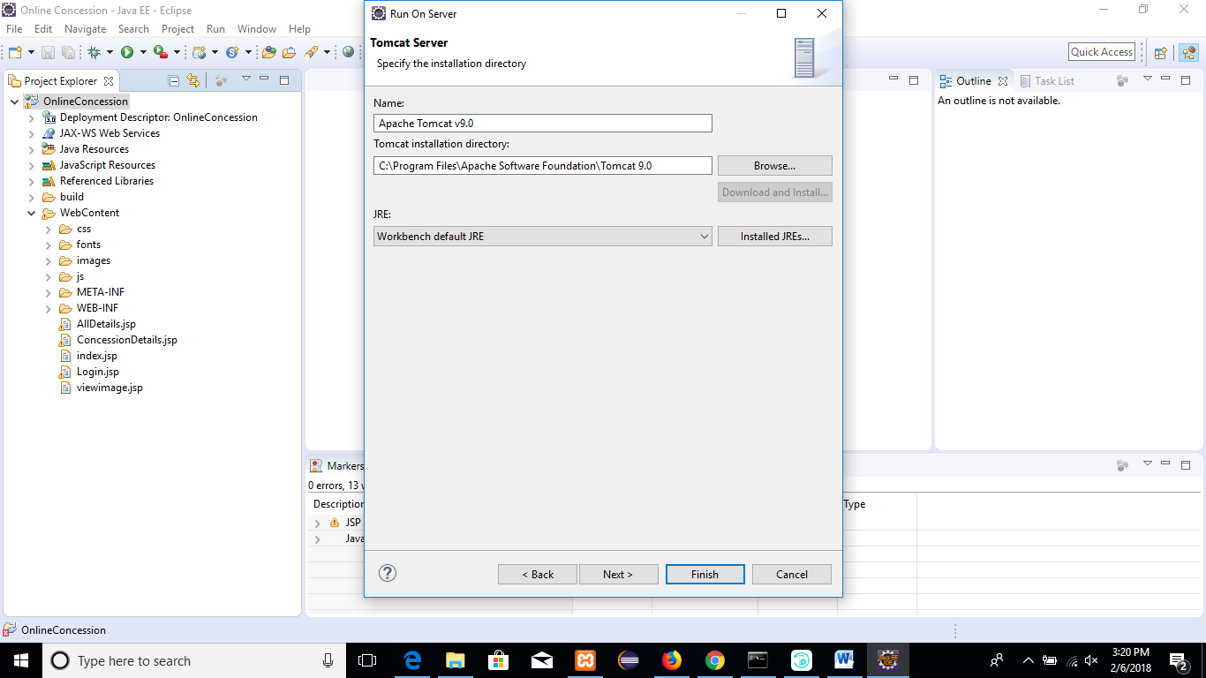

1. Finish

